Python install steps in conda

Wednesday, April 12, 2023

11:24 AM

1 . Open Anaconda promt

And create new environment

This environmnet will get stored in .conda folder

Venv is envronment name

conda create --name venv

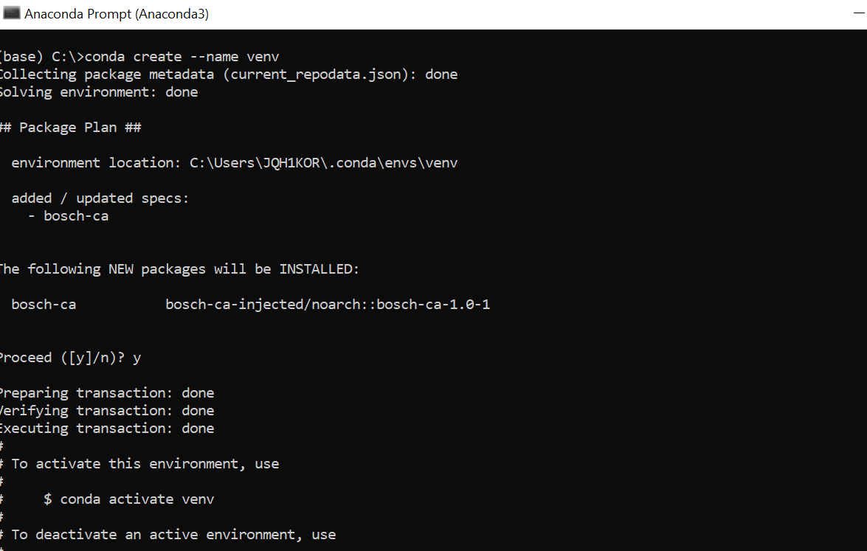

2 .

Then go to .conda folder and open venv folder and type cmd in path

It will open command promnt with that folder location

Then activate envirnmnent here

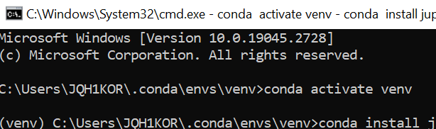

Then after activatiing environment - you can see it here above

then install Jupyternotebook

In this envirmen t

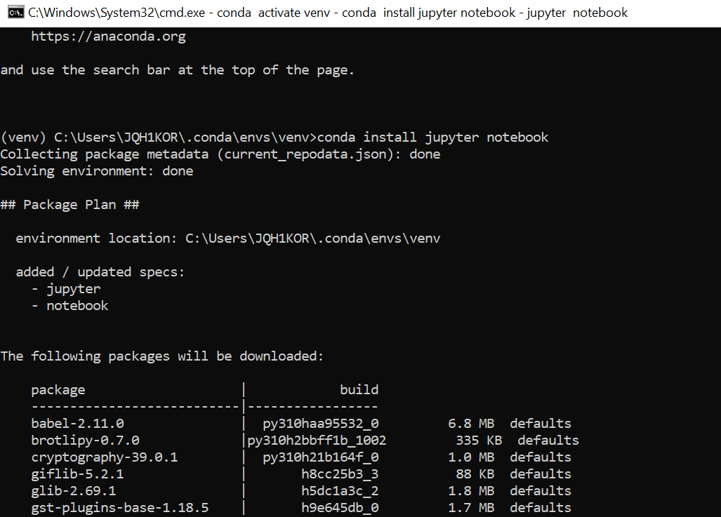

After Jupyternotebook installed

Type Jupyternotebook to open in browser

(venv) C:\Users\JQH1KOR\.conda\envs\venv>jupyter notebook

After opening jupyter notebook in browser then install packages what ever you need

Using requiremnts.txt file to install packages

Using conda : conda install --yes --file requirements.txt

Using pip : pip install -r requirements.txt

Step -1 : install PIP

Go to terminal in jupyternotebook and type below

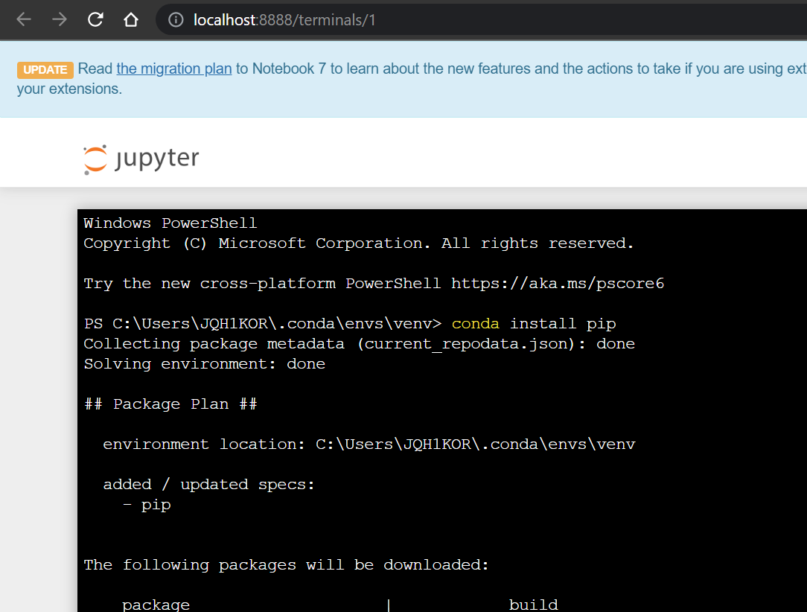

Once PIP install is done

Then install any packages using PIP

Eg : pip install pandas

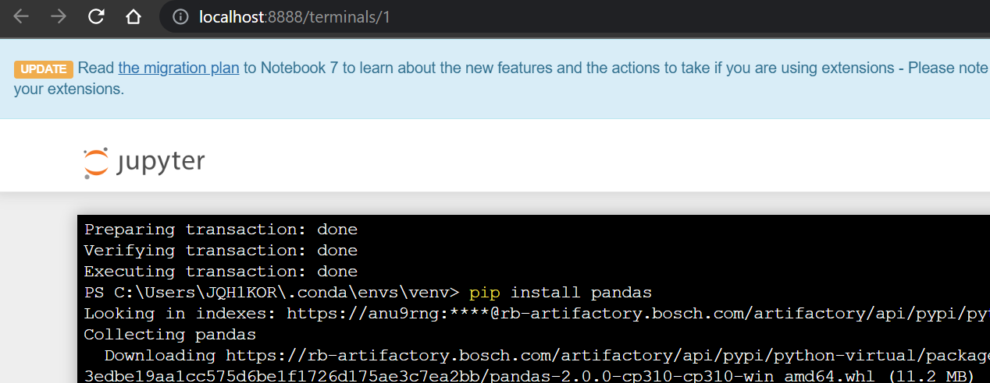

Then once done - Go to jupternotebook cell and type Import Padas

That’s it you can now use Padas in your jypternotebook

NEXT time want to open from scratch

Jus go to conda folder venv folder as below

And type cmd in the path and press enter

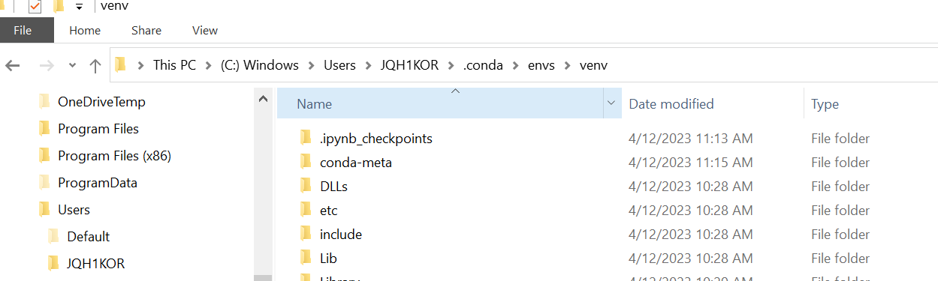

After opening command promt -

Activate venv environmant

Then open juypternotebook as below

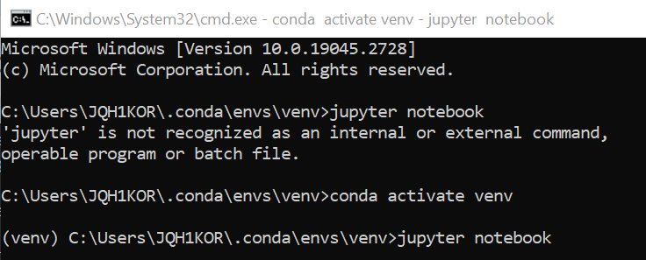

If you find issue :

<https://medium.com/@nrk25693/how-to-add-your-conda-environment-to-your-jupyter-notebook-in-just-4-steps-abeab8b8d084>

Happy coding

<https://stackoverflow.com/questions/68163848/how-to-install-packages-from-requirement-txt-in-python-using-anaconda>